**A Report about the sales & profits in a corporate department-store based in the US**

**Basic information about the data**

A quick glance on the data row data sheet it is clear that this is the gather information about a department store based in the United States that produces a range of products and ships nationally.

The data presented outlines sales figures across furniture, office supplies, and technology sectors over a four-year period. While furniture sales demonstrated steady growth throughout the period, office supplies experienced fluctuations, initially rising before declining in the final year. In contrast, technology sales consistently increased over the four years, reflecting evolving market trends and consumer preferences. Overall, the data highlights the importance of adaptability in navigating shifting market dynamics to sustain growth and capitalize on emerging opportunities.

**The purpose of the analysis**

The goal is the optimization of the resources in the department store to best fit with the increase in sales and overall performance. This is done through the analysis of the data then summarizing and reporting it as helpful spreadsheets as well as the answering inquiries about the data using pivot tables and sheet reports. The Results are presented in a pdf-report after the final analysis of the sales and profit of each product in each region and state in the US, concluded with the provided data of 4 years of sales and profits

*Please note that the data is a sample data downloaded from the internet it is not from a real company. I personally cleaned, organized and formatted the spreadsheet.*

**What products in each category sold the most in the previous 4 years?**

The expenditure report delineates a comprehensive breakdown of financial allocations across distinct categories, reflecting a strategic investment approach. Under the umbrella of furniture acquisitions, expenditures were channeled towards bookcases, chairs, furnishings, and tables, collectively amounting to $741,000. Office supplies, vital for operational efficiency, encompassed binders, paper, and storage essentials, tallying up to $511,886. Technological advancements were pursued through acquisitions in accessories, copiers, machines, and phones, culminating in a substantial investment of $836,154. This meticulous allocation strategy resulted in a grand total expenditure of $2,297,201, indicative of a balanced approach towards meeting diverse organizational needs.

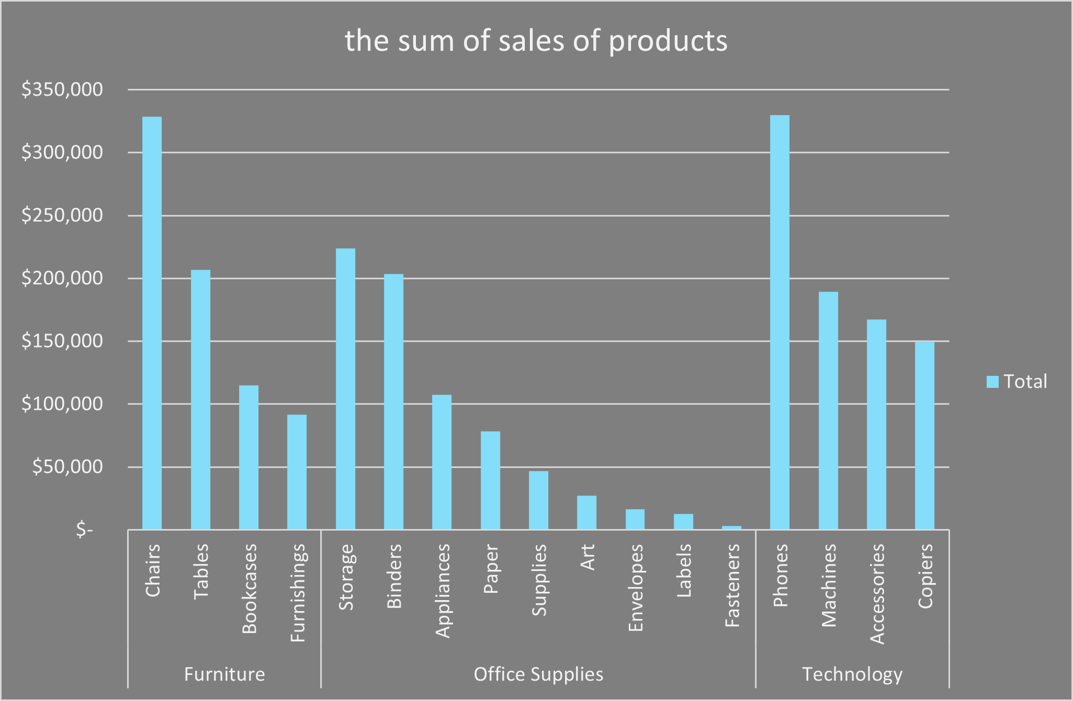

**In which state did the company have the most profit?**

The sales report provides insights into regional purchasing patterns across states. California leads with sales totaling $457,688, followed by New York with $310,876, and Texas with $170,188. Washington and Pennsylvania round out the top five with $138,641 and $116,512 respectively. Overall, these figures indicate varying levels of market activity across different regions, shaping strategic considerations for future sales initiatives.

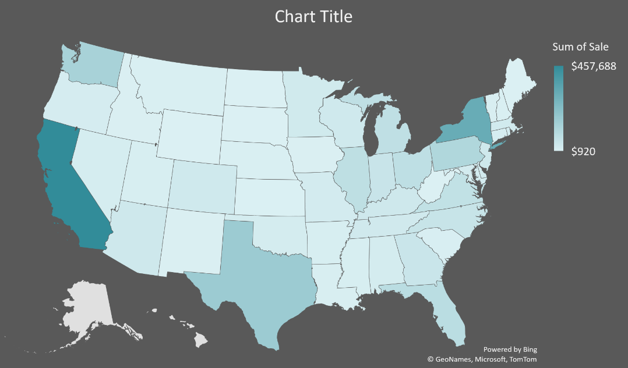

**What year was the most profitable in sales?**

Sales across furniture, office supplies, and technology sectors varied over four years. Furniture saw a steady rise from $157,193 in 2016 to $215,387 in 2019. Office supplies initially grew to $183,940 in 2018 but decreased to $246,097 in 2019. Technology sales increased consistently from $175,278 in 2016 to $271,731 in 2019, indicating evolving market dynamics and the need for adaptable strategies.

